Qatar will host excellent World Cup: Turkish envoy
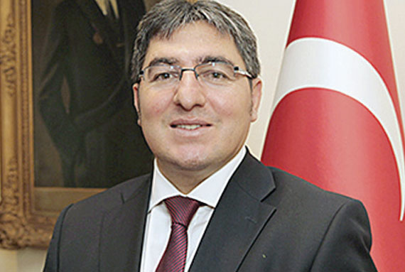

Ramy Salama
Doha
QATAR'S hosting of the 2022 World Cup is a coup for the Arab and Islamic worlds, and Turkey is confident that the country will live up to the challenge and host an excellent and successful sporting event in seven years' time, Ambassador of Turkey to Qatar HE Ahmet Demirok has said.
Speaking on Thursday at a lunch reception at his residence to commemorate the friendly match between the Qatari and Turkish national football teams, Demirok noted the close relations between the two countries and stressed his country's full support for Qatar's 2022 World Cup, expressing his expectation that the event would be a resounding success.
"Qatar's hosting of the 2022 World Cup can be considered a great achievement for the Arab and Islamic worlds. Turkey is proud of your great achievement in this regard, and we have no doubts and the utmost confidence that Qatar will spare no efforts and will successfully host an excellent tournament in 2022. We stand side by side with our Qatari brothers and are prepared to assist them in any way we can," he said.
Hinting at the success of the Qatar-Turkey 2015 Year of Culture, Demirok said,"The Year of Culture has seen around 40 engaging events thus far, with more to come in near future. Meanwhile, a friendly football match will be played between the national teams of Qatar and Turkey on Friday."
The lunch was attended by Qatar's Minister of Youth and Sports HE Salah bin Ghanem al Ali and a number of officials from the Qatari sporting world, namely President of the Qatar Football Association HE Sheikh Hamad bin Khalifa bin Ahmad al Thani, Secretary-General of the Qatar Olympic Committee Dr Thani al Kuwari, and Secretary-General of the Qatar 2022 Supreme Committee for Delivery and Legacy Hassan al Thawadi.
They were joined by officials from the Turkish Football Federation, including its President Yildirim Demiroren and First Vice-President Servet Yardimci as well as the Turkish national football team.
Addressing the attendees, Demiroren reiterated Turkey's support for Qatar's 2022 World Cup, saying,"football is not just a sport but also a means of forging connections between countries and people. Ever since we arrived in Qatar we have felt as if we are in our second country, and we are with our brothers in Qatar whenever they require anything from us. We enthusiastically support Qatar's 2022 World Cup and wish them every success in this regard".

